Operation instructions

1. Filters

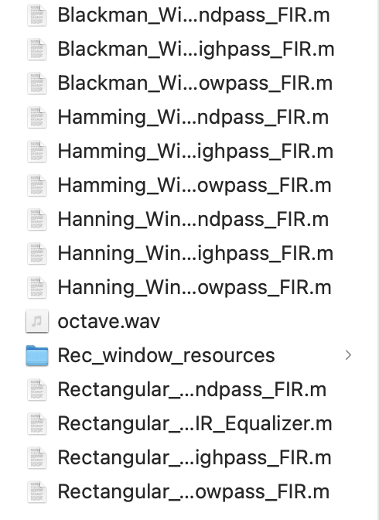

These are digital filter source code files based on four different window functions.

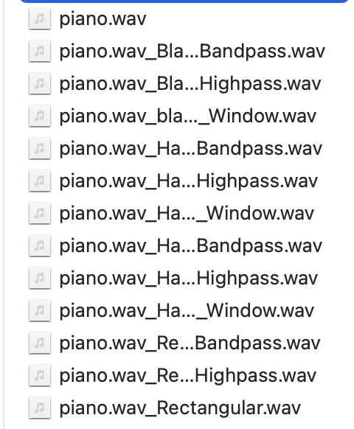

The first sound file is the original file, and the following is the audio file processed by different digital filters.

2.GUI：

Open the file ‘app3’

Step1:Set the window function and filter type

Step2:Set relevant parameters

Step3:Select the file that you want to process

Step4:The processing results will be displayed here

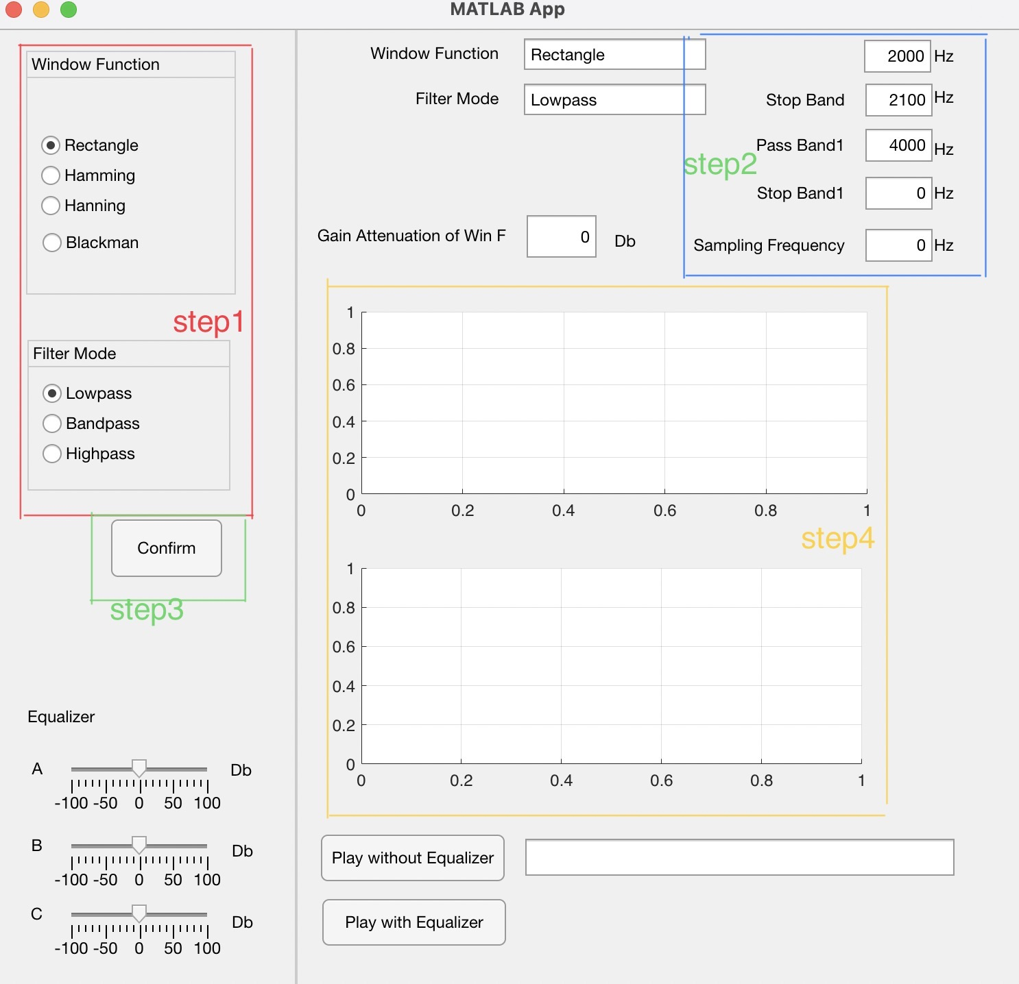

3.three-band equalizer：

Step1:A,B,C corresponds to gain/attenuation controlling the bass, midrange and treble frequency ranges respectively（0-1000，1000-2000，2000+）

Step2:Click on he button play with Equalizer ,then we can play the audio we want.If we click on he button play without Equalizer,then we can play the original audio.

